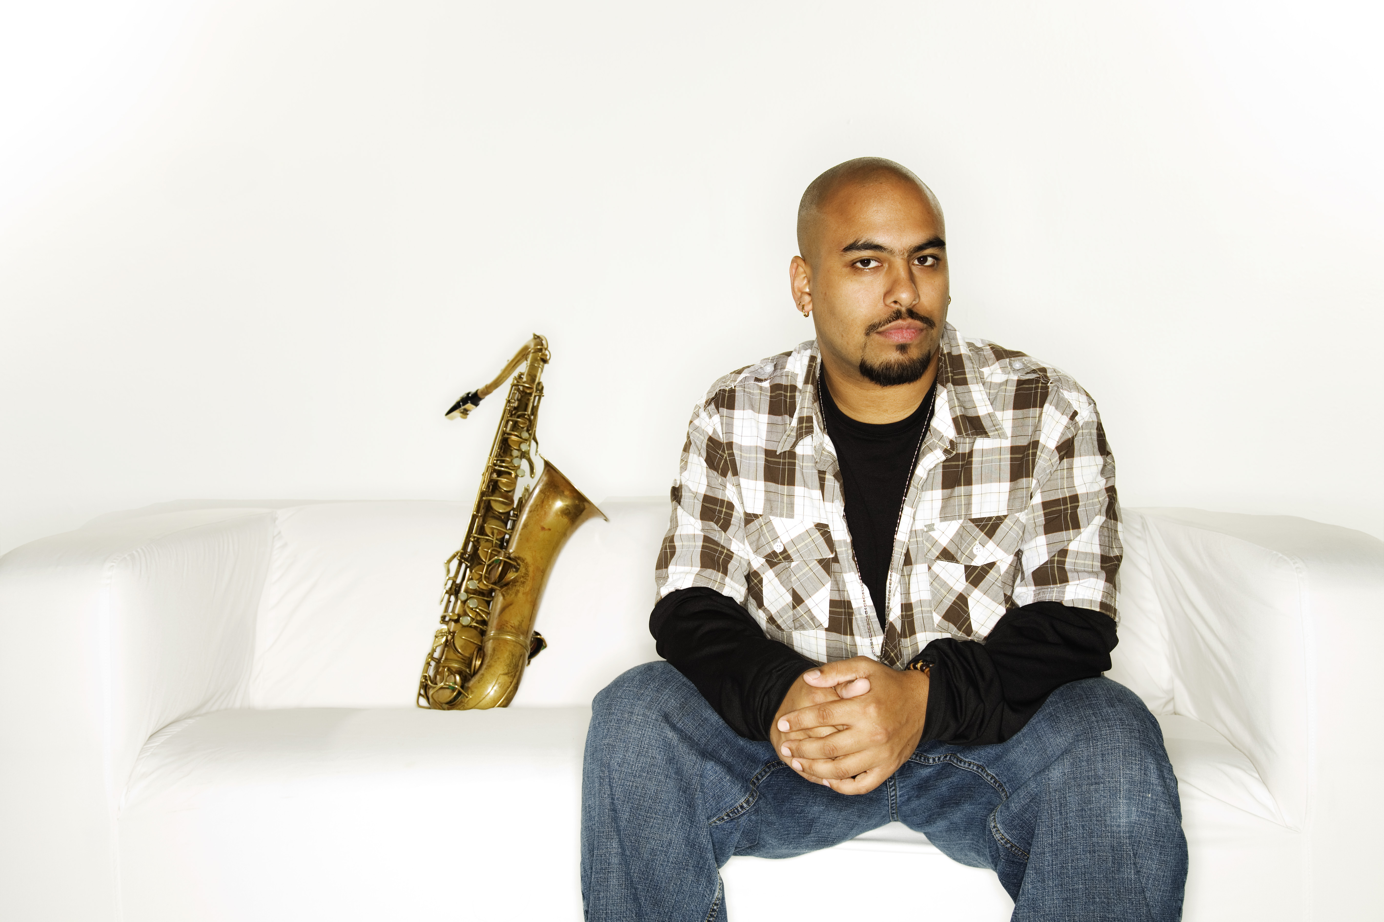
Troy Roberts – saxophone/composer/educator..
Hailing from the remote location of Perth, West Australia, saxophonist and composer Troy Roberts has received numerous awards including 3 consecutive DownBeat Jazz Soloist Awards and 2 consecutive West Australian Music Industry Awards, a Grammy Nomination medal (for Sammy Figueroa’s “The Magician”), and was the only Australian semi-finalist in the 2008 Thelonious Monk International Jazz Saxophone Competition. Graduating with a Bachelor of Music at the young age of 19, he has performed around Europe and the US extensively with artists such as James Morrison, Aretha Franklin, Jeff ‘Tain’ Watts, Sammy Figueroa, Dave Douglas, Orrin Evans and Robby Ameen to name a few, and also completed a Masters Degree at The University of Miami. In 2012, he shared the stage in an international septet comprised of jazz greats Wayne Shorter, Richard Bona, Vinnie Colaiuta and Zakir Hussein for Herbie Hancock’s launch of the first ever International Jazz Day at The UN General Assembly Hall. More recently he was also part of Hancock’s 2014 International Jazz Day held at Osaka Castle Park, Japan, sharing the stage with jazz luminaries such as Gregory Porter, Marcus Miller, Roy Hargrove, Esperanza Spaulding, Sheila E, John Scofield and Dee Dee Bridgewater. Troy is based in New York City, continues to maintain a busy performance and recording schedule around the globe, and is currently celebrating his 6th record as a leader, Secret Rhymes (Inner Circle Music).
Please visit www.troyroberts.com

(additional press material)

Roberts’ sixth release as a leader, "Secret Rhymes" is confirmation that redefinition of familiarity is entirely possible, and this will long be considered a new standard for years to come. This project embodies the spirit of contemporary improvised music in its purest and most urgent state, while maintaining the characteristics of nurturing and delicacy that give it balance and scope.
– Greg Osby

“Whilst it’s not common to display virtuosity, it’s even rarer to be wonderfully creative while doing so. But the rarest of all gifts is to have a unique voice; a sound that is unmistakably your own, Troy Roberts has this gift. He amply demonstrates that it’s possible to pay homage to the great tenor players of jazz and still create a fresh approach that leaves the listener always in anticipation of what he’ll come up with next.”
– James Morrison

“While jazz is so strongly identified as swing, it is nice to see the next gen carving out their sound and ideas. Roberts, along with his well-equipped ensemble, is certainly up to the task - creating a jazz record that employs great playing and abundant ideas. Roberts, though young in age, certainly has an arsenal of abilities under his belt, and has the makings and foundation of a lasting great saxophonist. Versatile in style, with a strong grasp of yesterday and today, he is a force to be reckoned with no matter the setting. He is more than one to watch, he is one to follow closely.”
– JazzTimes Magazine

“…Substance and style will triumph over pretentiousness and ego every time. Roberts has a resume that will certainly make one sit up and take notice having shared the stage with such luminaries as Nicholas Payton, Orrin Evans and John Clayton. Nu-Jive 5 is Roberts fifth release as a leader and is brimming with vitality and that certain pop of originality that separates the "artist" from the "musician…"

- Critical Jazz

“The music of Troy Roberts’ ‘Nu-Jive 5’ is an eclectic concoction of soul, R&B, electronica, gospel, and even glimpses of the 19th century romantic period – all musically glued together by each musician’s great sense of Jazz etiquette. However, the main concept behind the group is to serve as the meeting place of five great musical minds.”
–Troy Roberts

please visit www.troyroberts.com

(career overview)

EDUCATION

- Exceptional entrance into the West Australian Conservatorium of Music at age 15
- Bachelor of Music, West Australian Conservatorium of Music (2001)
- Masters of Music, University of Miami, USA (2007)

TEACHING

- 2003 – West Australian Conservatorium of Music – jazz saxophone
- 2004 – West Australian Conservatorium of Music – jazz saxophone
- 2005 – West Australian Conservatorium of Music – jazz saxophone
Wesley College – saxophone
University of Miami – jazz saxophone, freshman jazz ear-training, ens.
director
- 2006 – University of Miami – jazz saxophone, freshman ear-training, ens.
director, freshman improv.
- 2007 – University of Miami – jazz saxophone, freshman ear-training, ens.
director, freshman improv.
- 2008 – West Australian Academy of Performing Arts – jazz saxophone, ens.
director
- 2009 – West Australian Academy of Performing Arts – jazz saxophone, ens.
director.
University of Miami – jazz saxophone
- 2010 – University of Miami – jazz saxophone
New World School Of The Arts – guest artist in residence, ensemble director
- 2011 – University of Miami – jazz saxophone, ens. director
- 2012 – University of Miami – jazz saxophone, ens. director
- 2014 – The New School for Jazz & Contemporary Music – jazz saxophone

RECORDINGS

- 2001 – Hip Mo Toast Big Band, Hip Mo Toast Big Band – Live (MGM)
- 2002 – JazzWA Compilation, Jazzaziz Vol. 1 (Jazzaziz)
- 2003 – Salamanda, Adapt (Jusagroove)
Hip Mo Toast Big Band, Mischievous Girl (MGM)
James Morrison, On The Edge (Morrison Records)
James Morrison, On The Edge, Live @ The Opera House DVD (Morrison
Records)
- 2004 – VOID, Live At The Llama Bar DVD (XenDen Music)
James Morrison, Live at The Burghausen Jazz Festival, Germany DVD
- 2005 – Troy Roberts, Soul Garbage (Morrison Records)
VOID, VOID (XenDen Music)
- 2006 – Jean Caze, Miami Jazz Scene
- 2007 – Alex Alberti, Two Sides To Every Story
Sammy Figueroa, The Magician (Savant Records) (Grammy Nomination)
The South 9 Ensemble, The Llama
- 2008 – Jono McNeil, Places (Hit Town Records)
Johannes Luebbers Dectet, Make Some Noise
Troy Roberts, The XenDen Suite (XenDen Music)
- 2010 – Stephen Guerra, Namesake (Bada Beep Music)
Troy Roberts, The XenDen Suite – Live DVD (XenDen Music)
Valeria Proano, Retrato En Blanco Y Negro (Tie Records)
Dave Grusin, An Evening With Dave Grusin CD&DVD (Concord/Heads Up)
- 2011 – Aaron Spiers, Australique
John Trotter, The Working Drummer DVD
Troy Roberts, Nu-Jive (XenDen Music)
Silvano Monasterios, Unconditional (Savant Records)
- 2012 – Gaby Vivas, Ninth Life
Daniel Strange, Life As I Hear It
- 2013 – Troy Roberts, Nu-Jive 5 (XenDen Music)
- 2014 – Rony Afif, Zourouf
JC Styles, Blakey Grease (American Showplace Music)
- 2015 – Troy Roberts, Secret Rhymes (feat. Jeff ‘Tain’ Watts) (Inner Circle Music)
Jeff ‘Tain’ Watts, Blue, Vol. 1 (Dark Key Music)

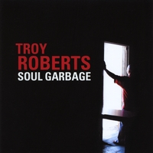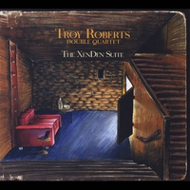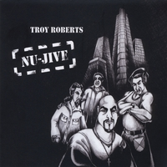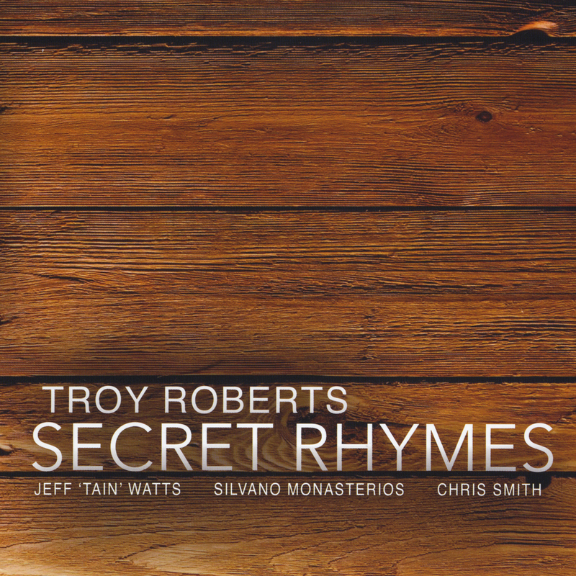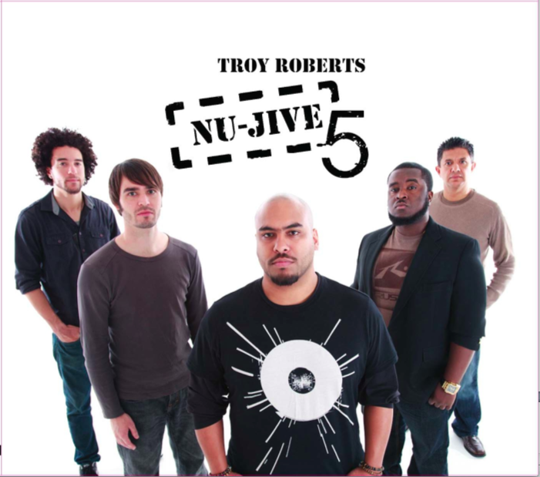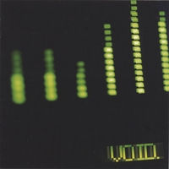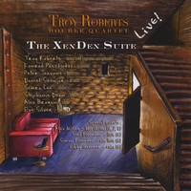

AWARDS

- 1999 – Perth Jazz Society Encouragement Award

- 2000 – Perth Jazz Society Encouragement Award

- 2001 – James Morrison Jazz Scholarship
Melville Toyota Jazz Scholarship
Bob Wyllie Jazz Scholarship

- 2003 – DownBeat Music Award – Jazz Soloist

- 2005 – Perth Jazz Society Award – Best Original Jazz Act (VOID)
WAMI Award - Best Original Jazz Act (Hip Mo Toast)

- 2006 – Downbeat Music Award - Group Performance
Downbeat Music Award – Jazz Soloist

- 2007 – WAMI Award - Best Original Jazz Act (VOID)
Downbeat Music Award – Group Performance
Downbeat Music Award – Jazz Soloist

- 2008 – WAMI Award - Best Original Jazz Act (VOID)
Finalist – Thelonious Monk International Jazz Saxophone Competition
Grammy Nomination for performance on ‘The Magician’

- 2009 – WAMI Award - Best Original Jazz Act (VOID

- 2010 – Perth Jazz Society Members Choice Award
Perth Jazz Society Best Jazz Performance Award (Troy Roberts Double Quartet)
DownBeat Music Award – Jazz Soloist

TOURS AND FESTIVALS

- 1999 – Performances with John Pisano, Frank Foster, James Morrison, Daryl
Summers

- 2000 – Performances with James Morrison, Daryl Summers, Rolph Harris,
Frank Bennett
Manly Jazz Festival - Sydney (with WAYJO)

- 2001 – Generations Jazz Festival - South Australia.

- 2002 – Fremantle Jazz Festival
Generations Jazz Festival - South Australia.

- 2003 – West Australian Regional Tour - James Flynn Band
Live recording at the Sydney Opera House - James Morrison
European Tour with James Morrison - Germany, Austria, Czeck, Switzerland, Aarlen Jazz Festival - Germany

- 2004 – Fremantle Jazz Festival with Ingrid Jensen (USA)
AUS & EUR Tours with James Morrison
Burghausen Jazz Festival - Germany (Live DVD)
Jazz In The Vines Festival – Sydney
Wangaratta Jazz Festival – Melbourne
Jazz meets the Symphony, James Morrison Sextet with WA Symphony
Orchestra

- 2005 – Performances - Kevin Mahogany, Gary Bartz, Christoph Spendel

- 2006 – Performances - Melton Mustafa, Slide Hampton, Dennis Macrell
EUR Tour wth J. Morrison - Sweden, Germany, Austria, Russia, U.K.
Villa Celimontana Jazz Festival with VOID - Rome, Italy
IAJE Conference, with Bop Brothers- NYC

- 2007 – Performances at The Jazz Standard, NYC with Sammy Figueroa
Performances - Robby Ameen, Lew Soloff, Duffy Jackson
EUR Tour wth J. Morrison - Italy, Austria, Switzerland, Germany
2 USA Tours with VOID - New York, Miami, Texas, California
IAJE Conference, with VOID – NYC
Houston International Jazz Festival with VOID

- 2008 – Perth Winter Arts Festival with VOID
York Soul and Jazz Festival with VOID, James Morrison, Troy Roberts
Monk Saxophone Comp with Carl Allen, Geoff Keezer, Rodney Whitaker

- 2009 – Performances wth Dave Grusin, Jeff Hamilton, John Clayton
Perth Winter Arts Festival with Troy Roberts Quartet
Opening of The Ellington Jazz Club (AUS)
Troy Roberts Double Quartet CD Launch, AUS and USA
A week at Dizzy’s Jazz Club, NYC wth Greg Gisbert

- 2010 – Performances with John Pizzarelli, Patti Austin
Burghausen Jazz Festival with Sammy Figueroa, Lew Soloff, Ronnie Cuber (Germany)
APAP Convention, wth Silvano Monasterios’ 4th World Ensemble (NYC)
Perth Winter Arts Festival with Troy Roberts Quartet (AUS)
Sunny Isles Beach Jazz Fest with Troy Roberts Quartet (USA)

- 2011 – South By South West Festival (Austin, TX)
Troy Roberts – ‘Nu-Jive’ CD Launch, AUS and USA
Silvano Monasterios – ‘Unconditional’ tour, Boston, NYC, Miami
(‘Nu-Jive’ hits #20 on CMJ Jazz Charts within 7 weeks)

- 2012 – Performances with Wayne Shorter, Zakir Hussain, Richard Bona,
Vinnie Colaiuta, Stephen Scott
International Jazz Day - UN General Assembly Hall, NYC
Exit O Jazz Fest with Orrin Evans, Nicholas Payton
Nu-Jive tour, Miami, NYC, Atlanta, Pittsburgh
Dizzy’s Jazz Club, Qatar with Brianna Thomas

- 2013 – Tour to Angola & Portugal with Linda Oh Quartet
Tour to Brazil & Canada with Sammy Figueroa & Chico Pinheiro
NU-JIVE 5 CD Release Tour, Florida, NYC, Atlanta, Pittsburgh, Maine, Perth International Jazz Festival
Performances with Orrin Evans, Ari Hoenig, Robby Ameen, Bob Hurst
Gospelfest 2013 with Aretha Franklin
Week residency at The Village Vanguard wth Jeff Tain Watts Quartet
Week residency at Dizzy’s Jazz Club, Troy Roberts Quartet

- 2014 – International Jazz Day – Osaka, Japan
recording and tours with Jeff ‘Tain’ Watts Quartet
Troy Roberts’ NU-JIVE at Perth International Jazz Festival and Melbourne International Jazz Festival
Week residency at The Village Vanguard wth Jeff Tain Watts Quartet
Wangarratta Jazz Fest (with Jeff ‘Tain’ Watts Quartet)

- 2015 – Thailand International Jazz Conference – Jeff ‘Tain’ Watts Quartet
Inaugural BAM Festival (Black American Music), Bari, Italy
Troy Roberts’ Quartet at Perth International Jazz Festival
(‘Secret Rhymes’ hits #8 on Top 40 Jazz Charts)

PRESS

- 2003 – DownBeat Magazine - June edition
Article in The West Australian
TV appearance on Australian Network 10 News - 2 news articles

- 2004 – Article in The West Australian
TV appearance on Australian Network 10 News - 2 news articles
Burghausen Jazz Festival, European TV Broadcast – Germany
TV appearance on 'Good Morning Australia' - Network 10, Melbourne

- 2005 – Article in The West Australian

- 2006 – DownBeat Magazine - June edition
TV appearance on 'Art Street' - WLRN Miami, Florida
Article in Miami New Times

- 2007 – DownBeat Magazine - June edition
TV appearance on 'Great Day Houston' - CBS Houston, Texas
Article in Miami New Times
3 articles in The West Australian

- 2008 – The West Australian
JazzTimes – performance review, USA

- 2009 – The West Australian
CD review in W.A. Seven Days Mag, and ABC Radio National
TV appearance on Australian Network 10 News – Ellington Jazz Club

- 2010 – Blogging Black America – performance review, USA
Musical Missing Piece – CD review, USA
DownBeat Magazine – June edition

- 2011 – ‘Nu-Jive’ album reviews – Gapplegate, O’s Place Jazz Magazine, Passing
Notes, Something Else, Midwest, Improvijazzation Magazine (USA)
Performance reviews – Jazz Corner, Musical Missing Piece, JazzTimes, All About Jazz, The International Review of Music (USA)
Artist Interview - Clarinet and Saxophone Society of Victoria – July edition

- 2012 – UNESCO International Jazz Day performance review – Jazzday.com,
Unesco.org, NPR.org

- 2013 – Performance reviews – Jazz Corner, JazzTimes, Something Else, All
About Jazz, The International Review of Music
‘Nu-Jive 5’ album reviews & CMJ Radio Charting archived by publicist
at http://karionpresskits.com/troyroberts2/accolades.html
- 2014 – Performance reviews – Jazz Corner, JazzTimes ( http://www.nytimes.com/2014/04/14/arts/music/jeff-tain-wattss-quartet-opens-series-at-mintons.html?action=click&contentCollection=Music&region=Footer&module=MoreInSection&pgtype=article&_r=1 )

