Pianist, composer, and Inner Circle Music and Creative Nation Music recording artist Lefteris Kordis was born in Athens, Greece. Since age four, and with the support and encouragement by his parents George and Peggy, he has studied, performed, and composed based on a spectrum of genres including Jazz, Western Classical, Modernist/Avant-Garde, Greek Folk, Byzantine chant (his grandfather was a cantor, whose brother directed a school of cantors), and Argentinean Tangos. His musical experiences include stints with Steve Lacy, Sheila Jordan, Joe Lovano, Greg Osby, Robin Eubanks, George Garzone, Dimos Dimitriadis, Joe Hunt, Takis Paterelis, Dimitri Vassilakis, as well as Greek composers Mikis Theodorakis and Dionysis Savvopoulos, Greek pop singers Fivos Delivorias, Aggelos and Stelios Dionysiou, Greek folk clarinet players Vasilis Saleas and Panayotis Haliyannis, pontian kemence players Matthaios Tsahouridis, Mihalis Kaliontzidis, Japanese shō player Ko Ishikawa, dancer Li Chiao Ping, textile design artist Sonya Clark, and numerous theater directors, actors and poets. Lefteris has premiered compositions by Yusef Lateef, John Mallia, Gene Coleman, Johannes Berauer, Greg Bullen, Ayn Inserto, and James Grant. These works involve free and structured improvisation, prepared piano, and pre-recorded and live electronics. From 1997 to 2002, Lefteris served as a pianist and transcriber/arranger for the Greek-based “Mi bemol Quintet” performing exclusively the music of Astor Piazzolla. He has also worked as a transcriber/arranger for the Dutch “Metropole Orchestra.”

Lefteris has appeared in such major venues as the Megaron of Music of Athens, Greece, Jordan Hall in Boston, Tsai Performance Center at Boston University, the Overture Center for the Arts in Madison, WI, the Cornelia Street Café in NYC, the Shapeshifter Lab in NYC, the UMO Jazz Club in Helsinki, Finland, the Touchill Performing Arts Center at the University of Missouri-St. Louis, the Vlahcevic Concert Hall at the Virginia Comm University, the Tinos Jazz Festival, the Museum of Fine Arts in Boston, the Megaron Gkyzi Festival in Santorini, the Fraser Performance Studio at the WGBH radio station, and he has appeared regularly with his jazz piano trio at the Beehive and the LilyPad in Boston (Top 100 World Jazz Clubs according to DownBeat).

Lefteris earned prestigious awards from the Fulbright, the Onassis, the Ruth Shapiro and the Gerondelis Foundations, which allowed him to move to the US to pursue a Master’s and a Doctorate degree at New England Conservatory of Music in Boston, MA, where he served as a professor and course developer from 2005 to 2013 at the Jazz, Music History/Musicology, and Music Theory departments. Extremely instrumental to his spiritual and artistic growth were teachers/mentors Danilo Pérez, Steve Lacy, Allan Chase, Frank Carlberg, Bob Brookmeyer, Ran Blake, Jerry Leake, Dimos Dimitriadis, and Charlie Banacos, When Banacos passed away in 2009, Lefteris decided to devote his doctoral dissertation to document Banacos’s pedagogy of jazz improvisation. Currently, he is researching about and writing a book on Danilo Pérez’s teaching approach and philosophy through the Panama Jazz Festival, the Danilo Pérez Foundation, and the Berklee Global Jazz Institute in Boston, MA.

Lefteris teaches improvisation, composition, and theory privately at his home studio in Brookline. He also teaches theory at the New England Conservatory prep school. He is performing the organ and directs the gospel choir at the Rush Memorial AME Church in Cambridge, MA. Also, Lefteris and his wife Panayota organize the “Café Aman Fest,” a Mediterranean Folk Music Festival that occurs bimonthly at Athan’s Bakery in Brighton, MA. Participant musicians are from Greece, Turkey, Italy, Syria, Israel, Armenia, US, and others. The main scope of the Festival is to create a community of musicians and audiences.

Lefteris has presented lectures and masterclasses at University of Missouri - St. Louis, UMASS Amherst, UMASS Boston, University of Rhode Island, Ionian University in Greece, and Walnut Hill Music School, MA. He has organized and/or performed in benefit concerts and fundraising events, and he has provided music for people with mental disabilities and the elderly in asylums and senior homes respectively both in the US and Greece. He has recorded six CD albums as leader or co-leader, and has appeared in numerous venues and festivals in Europe and the United States.

"A pianist with skill, touch, musicality and a gift for making songs from songs. Plus, he can swing! Give a listen" ~ Bob Brookmeyer

"A young pianist & composer who has demonstrated an exceptional creativity, in both his playing & his writing, as well as showing us all, his very strong commitment & motivation to aim for high musical goals. Talent like his is rare." ~ Steve Lacy

“Lefteris has the ability to improvise within the jazz tradition adapting to the unique needs of each musical situation, and to freely and eagerly dive into unknown musical territories, not afraid of taking risks.”
~ Danilo Pérez

“Kordis made his miracle! [Songs for Aesop’s fables] He carries multi-genre and multi-cultural musical influences, all of which are essential to be a creative, complete and multi-dimensional musician.”
~ Dimitris Trikas (popaganda.gr - December 14, 2014)

"Pianist Kordis is a masterful musician whose nimble mind can perform the most amazing spontaneous improvisations on any given theme, lightning fast in his fingering and always in precise coordination with the singer and others. He is quite a phenomenon!"
~ David K. Rodgers (Hardwick Gazette, August 17, 2011)

"Kordis is the real discovery on this album [Paolo Lattanzi's Multitude, feat. Robin Eubanks], his playing is brilliant throughout whatever the tempo and he exhibits genuine ability as both soloist and accompanist. He's certainly a player I'd like to hear more of."
~ Ian Mann (The JazzMann.com - March 2010)

“Lefteris Kordis danced through his solo on the piano, the sweet tinkling of the upper register bringing buoyancy to the overall mood of the ensemble. His playing brings to mind the tapping of a finch, moving lightly and quickly across the keys”
~ Rebecca Buxton (review on live performance with Petros Klampanis’ Contextual group feat. Greg Osby at the Cornelia Street Café, New York, Oct. 10, 2012)
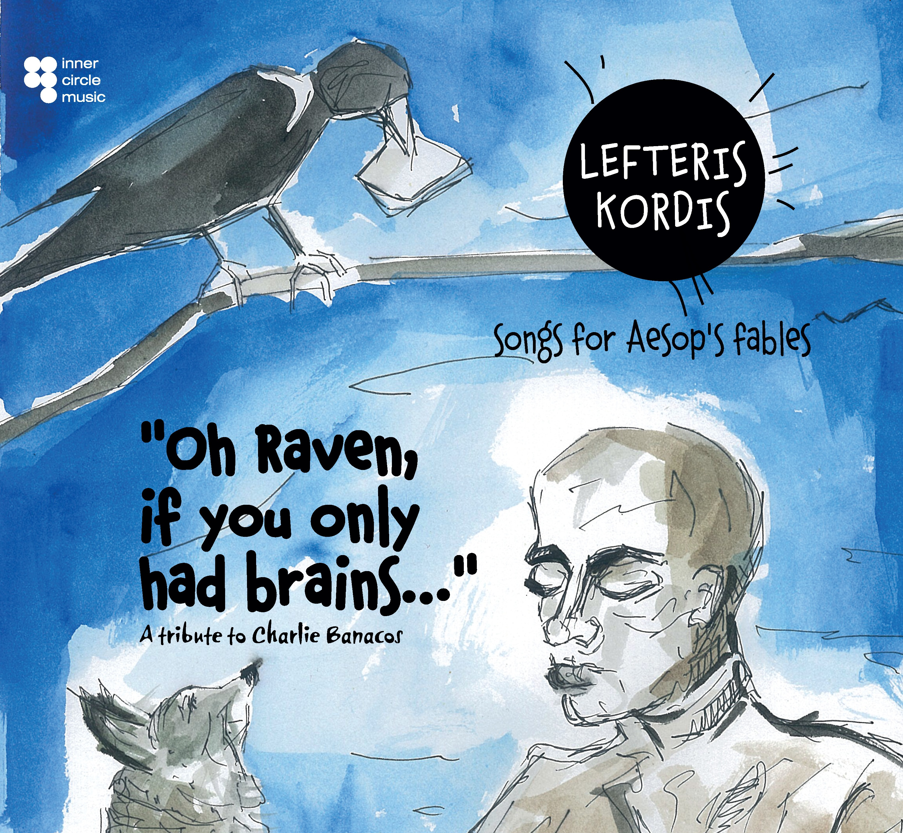

Links to CD purchase:

http://www.cdbaby.com/cd/lefteriskordis

New Upcoming ICM Release (Fall 2015)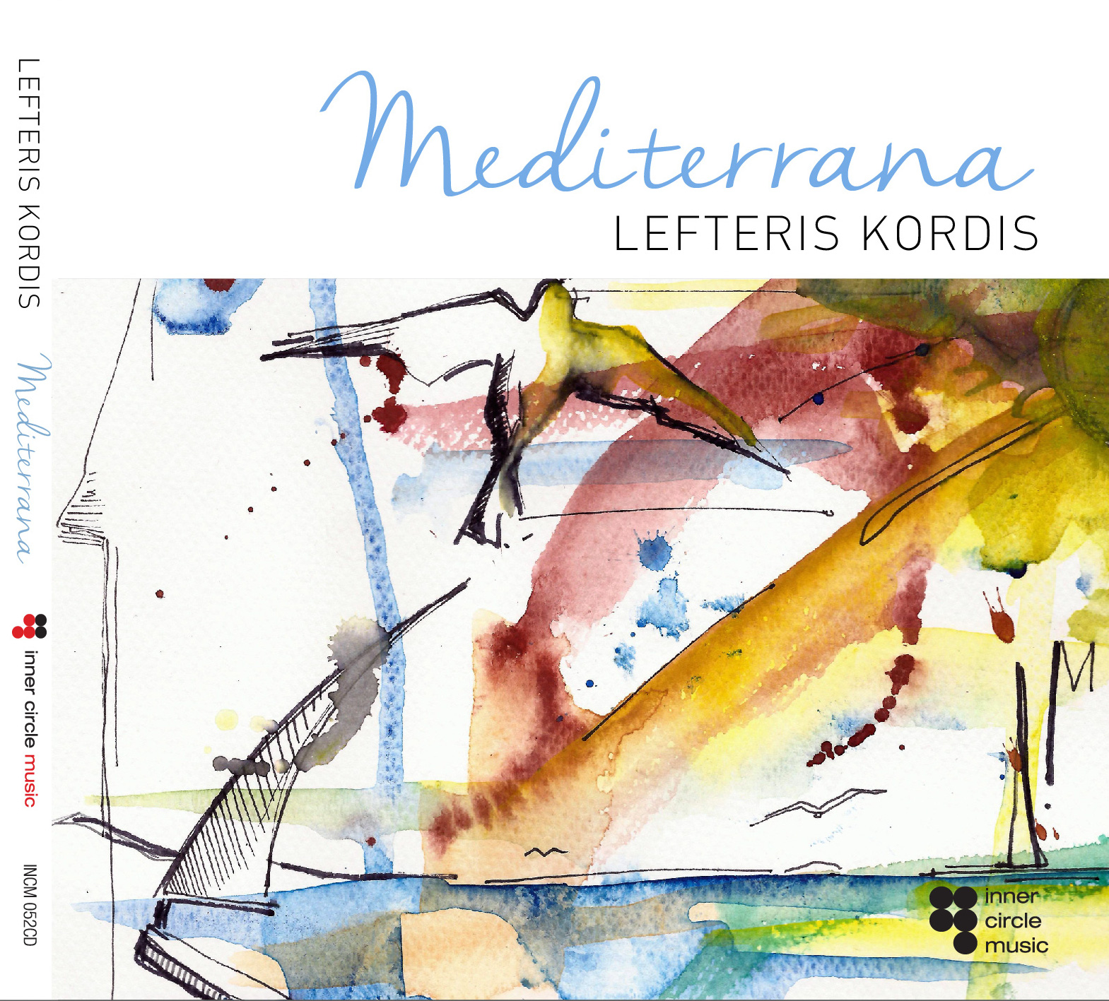


The EPK of Trio is here:
https://youtu.be/l3WGyCEwq5Y

